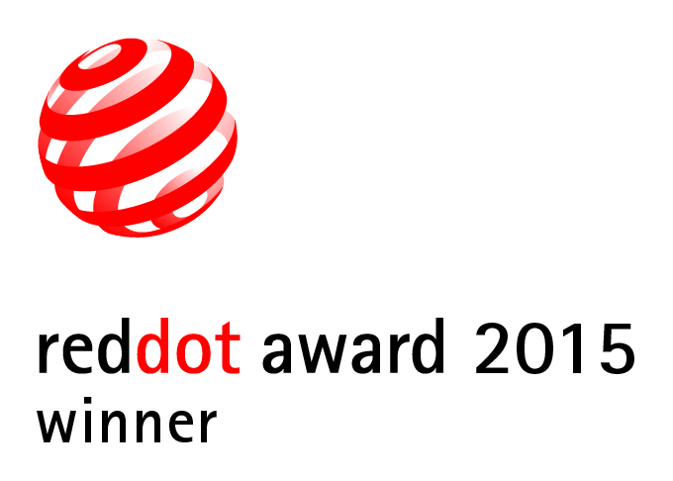

Electrolux Professional raises the bar with a new Red Dot Design Award

The green&clean Hood Type dishwasher wins coveted Red Dot Award: Product Design 2015

Pordenone, Italy, April 2015

For the second year in a row, Electrolux Professional has maintained its strong track record of winning submissions for the Red Dot Design Award.

After the success of the thermaline M2M - Made to Measure being recognized as Best of the Best for highest quality and ground-breaking design in 2014, this year it is the turn of the dishwashing category: the green&clean Hood Type dishwasher won the prestigious Red Dot Award: Product Design 2015.

The international Red Dot jury, composed of accomplished designers, design experts and specialist journalists from all around the world, evaluated 4,928 innovative entries from 56 countries and awarded the Electrolux green&clean Hood Type dishwasher for its high quality design.

“We are honored to receive the prestigious Red Dot: Product Design Award 2015”, says Michele Cadamuro, Design Director at Electrolux Group Design. “This award is a welcome addition to the exceptional recognition achieved by the thermaline M2M - Made to Measure last year, and clearly shows how Electrolux Professional can make the difference and successfully measure itself against the best in the industry for its design excellence”.

“We pride ourselves on industrial design that is innovative and developed around customer needs: simple, ergonomic and intuitive for a worry-free user experience,” adds Riccardo Marzapani, Electrolux Professional Head of Dishwashing Category.

The competition will culminate in the glamorous Red Dot Gala and at the subsequent Designers’ Night in Essen, Germany on 29 June 2015. The winning products will be then presented at the Red Dot Design Museum Essen from 29 June to 26 July in the impressive special exhibition “Design on Stage” displayed in the midst of the historical industrial architecture of the Zollverein World Heritage site, before being included in the museum’s permanent exhibition. Moreover, the green&clean Hood Type will be presented at the Red Dot Design Museum Singapore, the largest design museum in Asia.

About the Red Dot Design Award
With the Red Dot Design Award, which celebrates its 60th anniversary this year, the Design Zentrum Nordrhein Westfalen created one of the best-respected design competitions in the world. The sought-after award, the “Red Dot”, is the revered international seal of outstanding design quality. Further information at www.red-dot.org/press.

Electrolux Professional offers food service and laundry solutions to a wide variety of customers around the world, from restaurants and hotels to healthcare and other service facilities. Our 2,000 service partners in 140 countries ensure that our resource-efficient equipment, leading in innovation and design, improve our customer's everyday business. In 2013, Electrolux Professional had sales of EUR 640 million, 2,600 employees, 7 factories and over 1,000 dealers. For more information, visit www.electrolux.com/professional.

